**IT24101361 lab_06**

Q1)

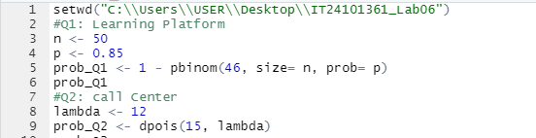

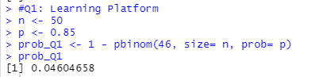

Q2)

